**High Level Design**

**Deloitte Case Study**

|  |  |
| --- | --- |
| **Written By** | **Nitish Pandey** |
| **Document Version** | **1.0** |
| **First Revised Date** | **04/05/2024** |
|  |  |
|  |  |

**DOCUMENT CONTROL**

**Change Record:**

|  |  |  |  |
| --- | --- | --- | --- |
| **VERSION** | **DATE** | **AUTHOR** | **COMMENTS** |
| 1.0 | 04 May 2024 | Nitish Pandey |  |
|  |  |  |  |

**Contents**

**Document Version Control......................................................................................................... 2**

**Abstract ...................................................................................................................................... 4**

**1 Introduction ............................................................................................................................ 5**

**1.1 Why this High-Level Design Document? ......................................................................... 5**

**1.2 Scope ................................................................................................................................ 6**

**2 General Description ................................................................................................................ 6**

**2.1 Product Perspective & Problem Statement ..................................................................... 6**

**2.2 Tools used ......................................................................................................................... 7**

**3 Design Details ......................................................................................................................... 8**

**3.1 Functional Architecture .................................................................................................... 8**

**3.2 Optimization ...................................................................................................................... 9**

**4 KPIs ......................................................................................................................................... 10**

**5 Deployment ........................................................................................................................... 10**

**Abstract**

It is used as a collective term to refer to a broad range of economic services provided by the finance industry, which encompasses a broad range of organizations that manage money, including credit unions, banks, credit card companies, insurance companies, consumer finance companies, stock brokerages, investment funds. A banking domain is comprised of all the components needed to run a financial service end-to-end. It covers the transaction and distribution process; the ways in which customers interact with the system, products, and services the organization offers; and the technology involved.

Accurately predicting the year of year (YoY), inflation and compound annual growth rate(CAGR) on different countries for different years with the help of given data sets CPI, EXCHANGE and EXPORTS. By taking these 3 values we can visualize and create insights for YOY, CAGR and INFLATION. we can also find some relations between them.

**1 Introduction**

**1.1 Why this High-Level Design Document?**

The purpose of this High-Level Design (HLD) Document is to add the necessary detail to the current project description to represent a suitable model for coding. This document is also intended to help detect contradictions prior to coding, and can be used as a reference manual for how the modules interact at a high level.

**The HLD will:**

• Present all of the design aspects and define them in detail

• Describe the user interface being implemented

• Describe the hardware and software interfaces

• Describe the performance requirements

• Include design features and the architecture of the project

• List and describe the non-functional attributes like:

o Security

o Reliability

o Maintainability

o Portability

o Reusability

o Application compatibility

o Resource utilization

o Serviceability

**1.2 Scope**

The HLD documentation presents the structure of the system, such as the database architecture, application architecture (layers), application flow (Navigation), and technology architecture. The HLD uses non-technical to mildly-technical terms which should be understandable to the administrators of the system.

**2 General Description**

**2.1 Product Perspective & Problem Statement**

A banking domain is comprised of all the components needed to run a financial service end-to-end It covers the transaction and distribution process; the ways in which customers interact with the system, products, and services the organization offers; and the technology involved.

The objective of the project is to perform data visualization techniques to understand the insight of the data. This project aims apply various Business Intelligence tools such as Tableau or Power BI to get a visual understanding of the data and helps in getting the clear insights from the data.

**2.2 Tools used**

Business Intelligence tools and libraries works such as Excel, Power BI are used to build the whole framework.

 

**3 Design Details**

**3.1 Functional Architecture**

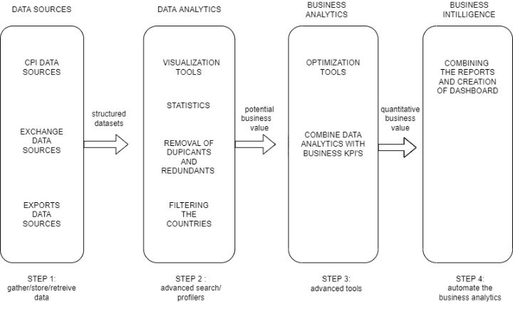

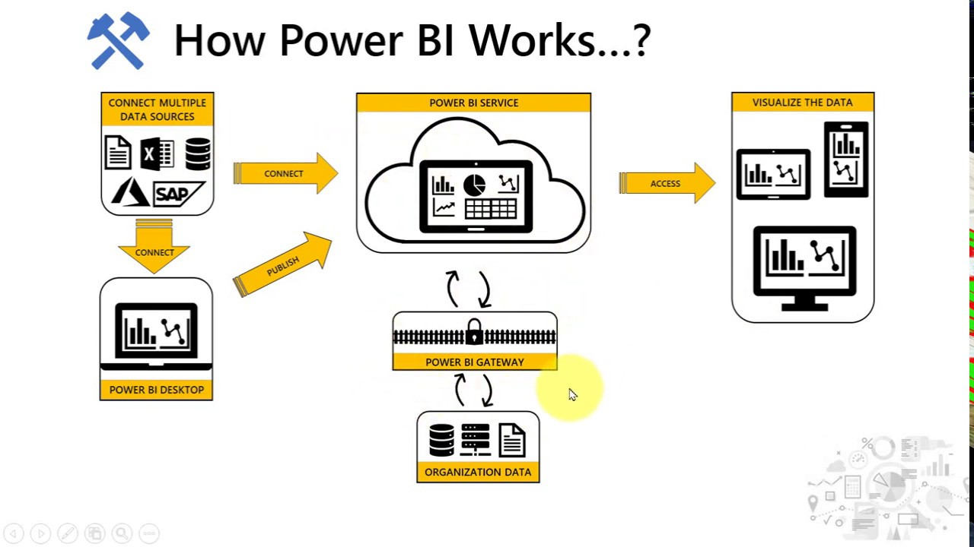

**3.2 Optimization**

* Removal of NaN from from the datasets.
* Conversion of monthly data to yearly and quarterly data.
* Filtering the countries
* Reshaping the data from wide data type to long data type for analysis

**4 KPIs**

Key indicators displaying a summary of effect on different countries by CPI, EXCHANGE and EXPORTS rate

1. Impact of inflation of different countries

2. Calculation of compound annual growth rate on different countries for different year (1998 to 2017)

3. Calculation of year of year growth rate on different countries for different year

4. Impact of exchange rate on different countries for different year

5. Impact of export rate on different countries for different year

**5 Deployment**

Migration of the data sources to Power BI cloud allows for the deployment of a link through which users can access the interactive visualization. With the deployed link, users can select any country and year from the available range of 1998 to 2018. Once the country and year are selected, users can easily analyze the inflation data for that specific country and year. Additionally, users can obtain information on the Compound Annual Growth Rate (CAGR) and Year-over-Year (YOY) growth for each country.

**6 Scope**

Adding the new measure values to data sources where we can easily predict the rank of the different countries in business and economic growth. We should be able to know the investments on the country based on its rank and also, we should able to know the factors which affect the inflation rate so that we can take actions accordingly. Not only these by adding new measures user can analyze the data in more beautiful way